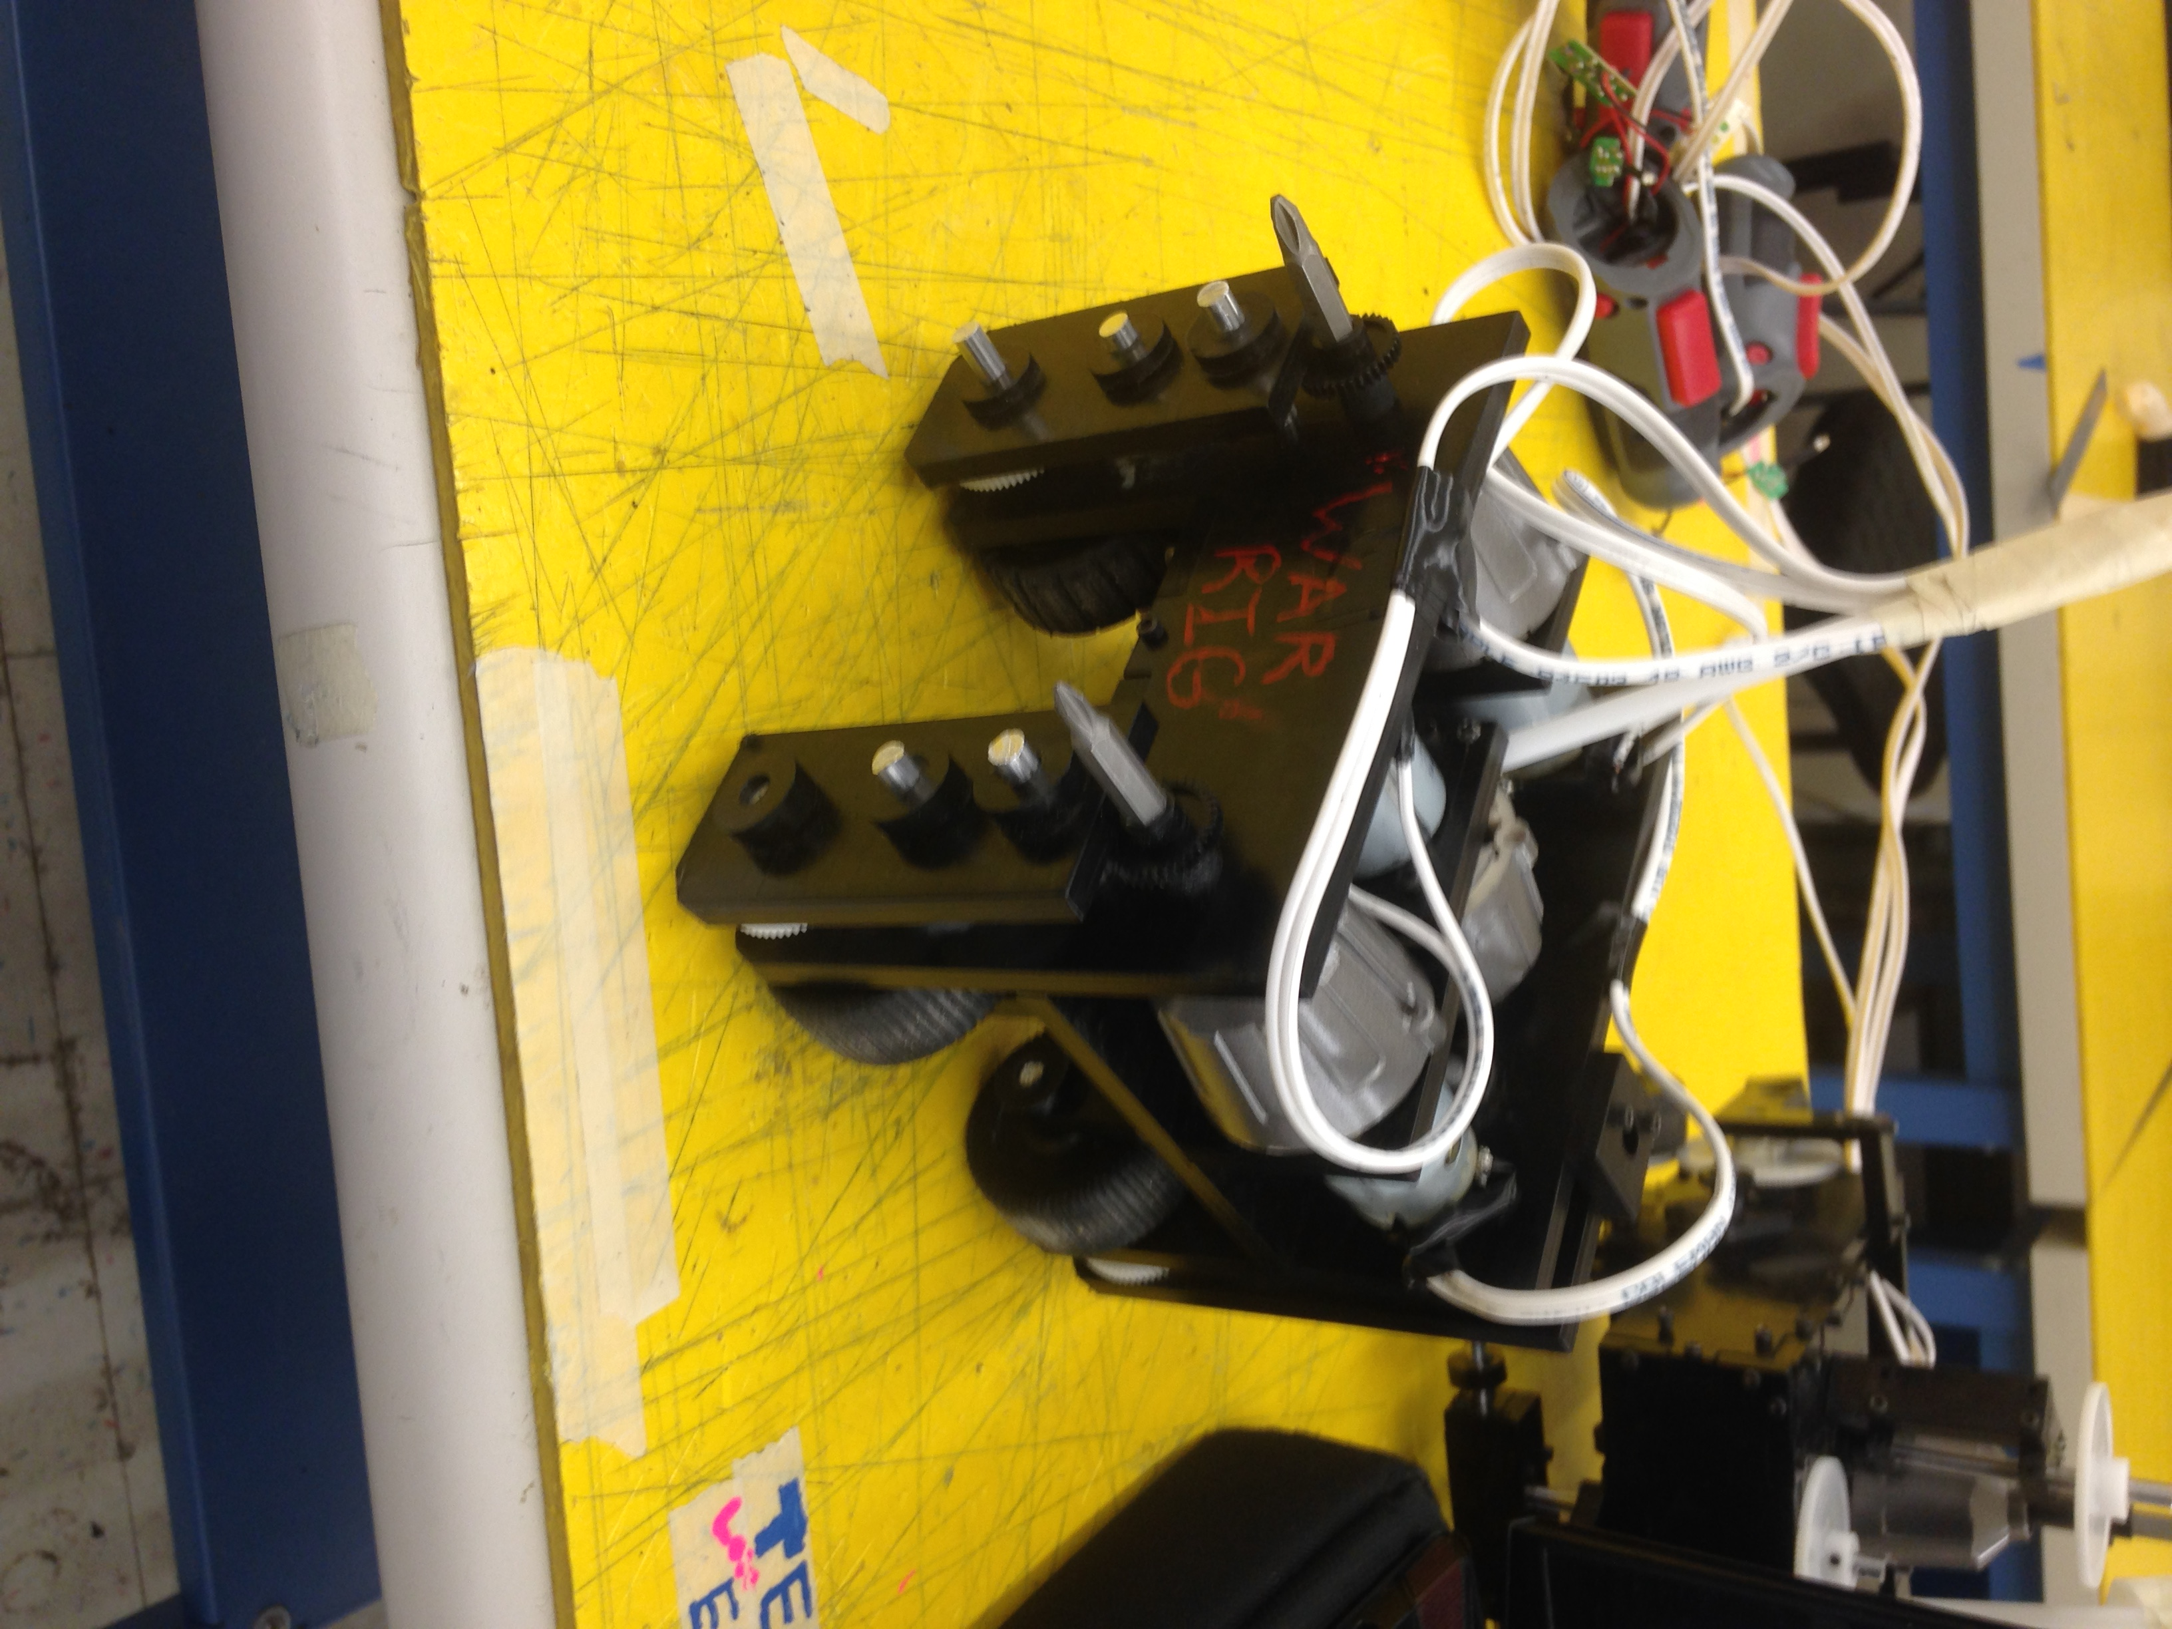

**Lab #3 – ATV**

T1—“War Rig”

Sierra Jackson, Stuart Monk, Zeb Mehring

MENG 185: Mechanical Design

10 May 2016

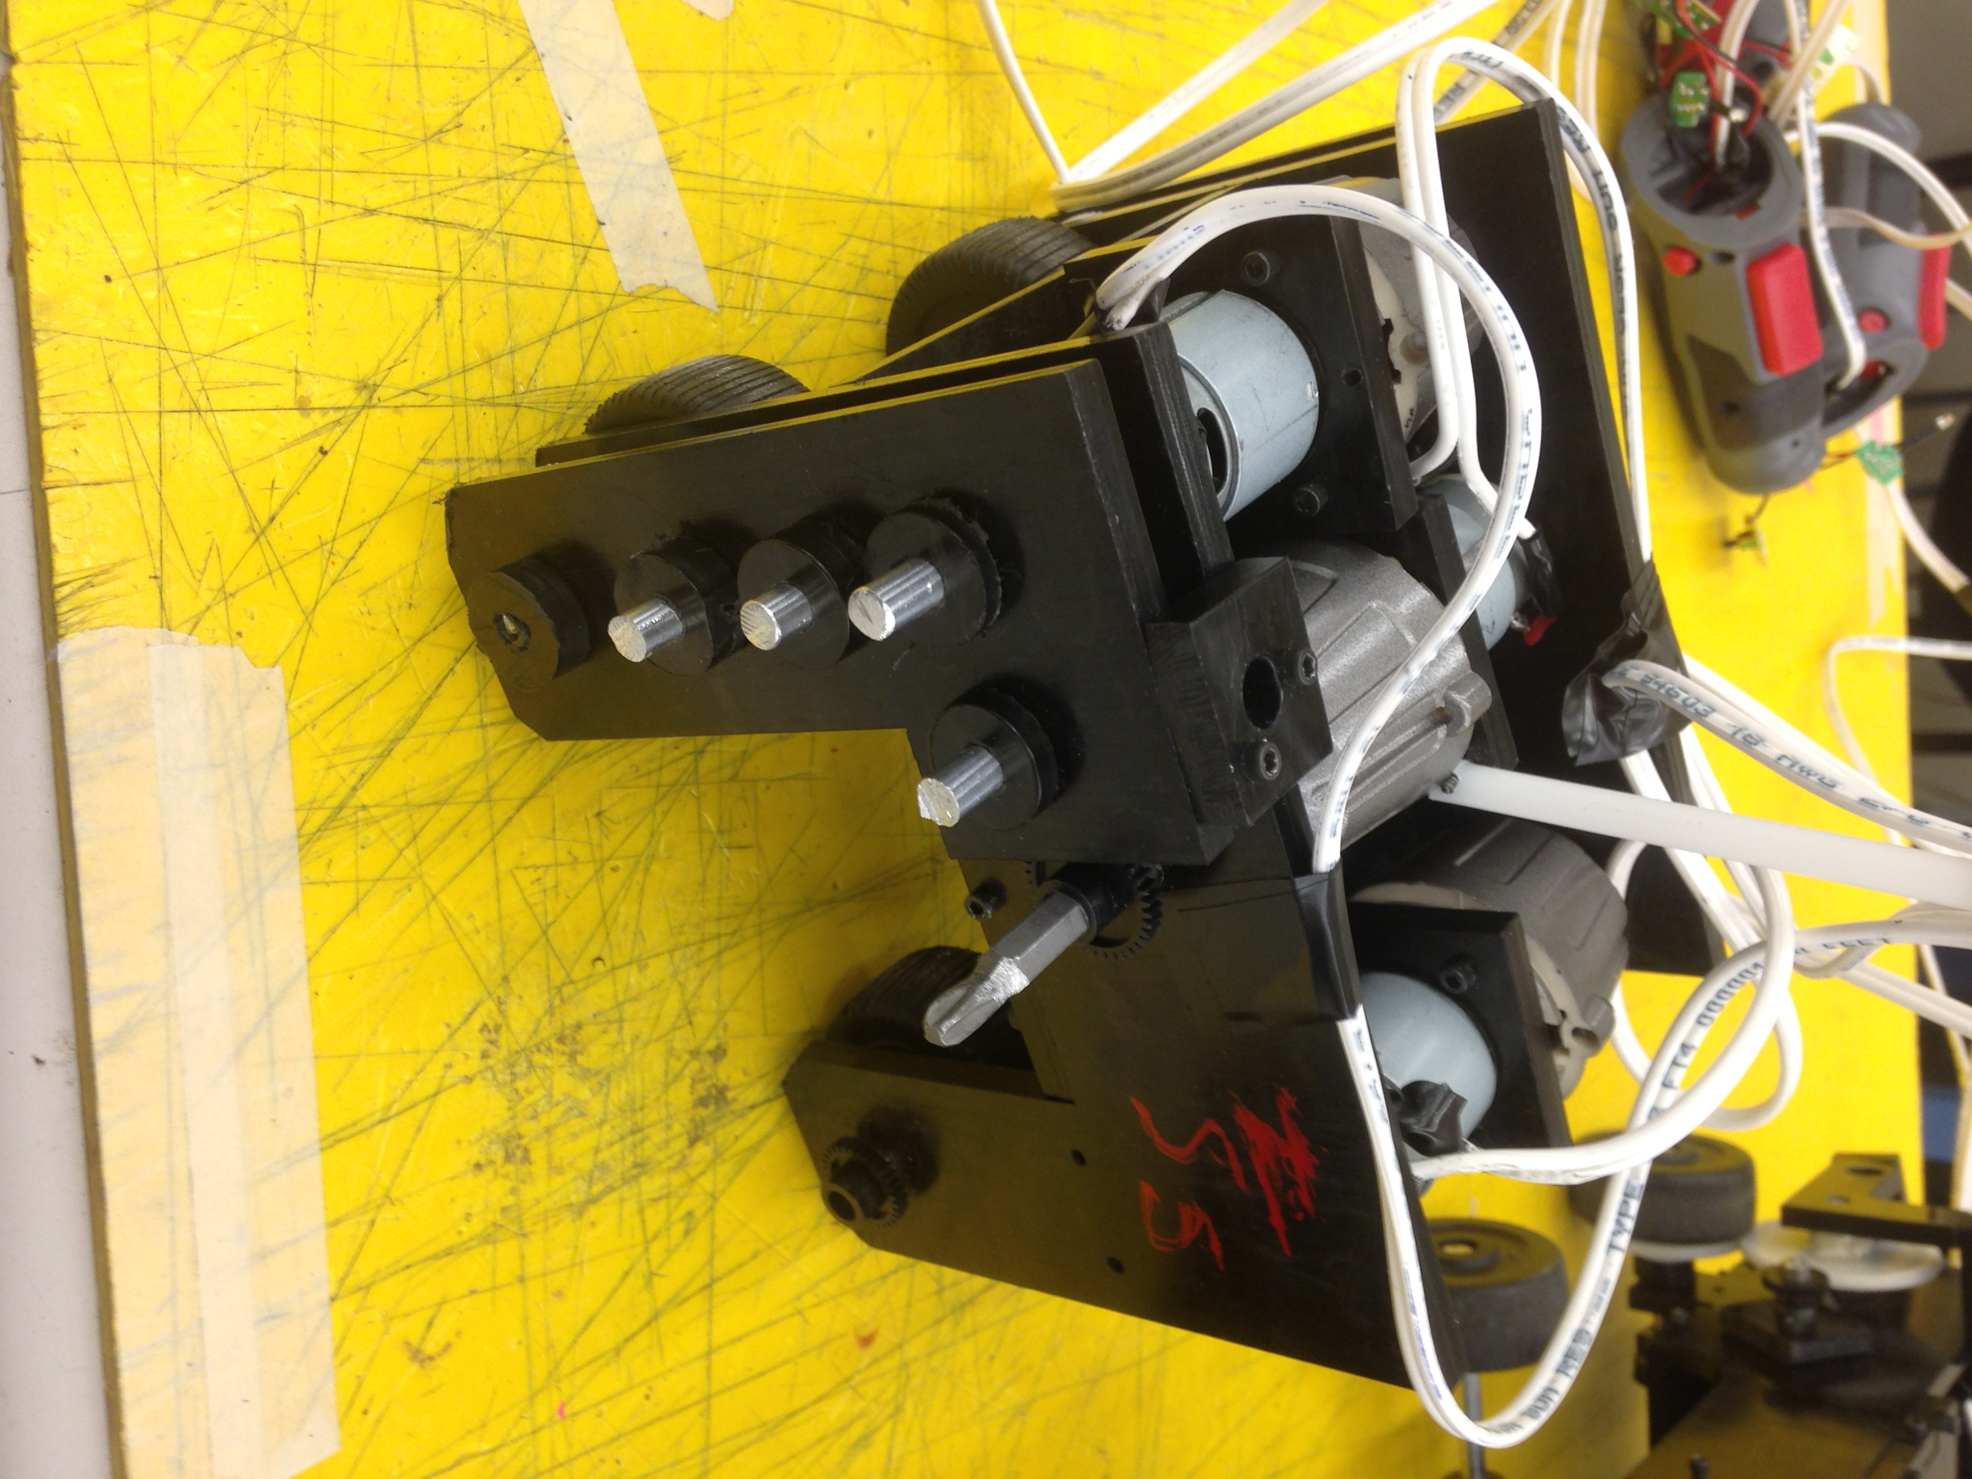

**Overview:**

The ultimate objective of this lab was to build an ATV capable of traversing a pre-specified obstacle course. To construct it, we were given three power screwdrivers, a sheet of Delrin (equivalent to 12x12” in surface area), three feet of a .25” diameter aluminum rod, wheels, screws, and $80 with which to purchase plastic gears.

Our approach was to create a three-wheeled vehicle driven by all three motors from the power screwdrivers. The steering is differential: it is accomplished by modulating the turning of the front motors by the driver. The gear ratio was calculated based off of the estimated necessary torque increase, and idle gears were added to raise the chassis base and increase the undercarriage clearance. A combination of screws and “puzzle geometry” were used to lock the chassis into place, while axles held between two or three supporting walls served as mounts for the gears and wheels. The wheels were given treads to increase traction and because treads (along with the battle spikes a.k.a. drill bits) look awesome.

The goals for this design were: to create a vehicle that could provide a high torque (we erred on the side of completing the course rather than going for record-times), to make a simple steering system that did not rely on the proper operation of a single motor and its gear train, to minimize the total volume occupied by the vehicle to increase the error margin resultant from the driver, and to build a model that would be sturdy enough to withstand multiple bouts of practice and competition. The final product, though it veered from the ideal conceptual design, achieved most of these goals.

**Design Specifications:**

|  |  |
| --- | --- |
| **Specification** | **Dimension** |
| Mass | 1.8 kg |
| Undercarriage Clearance | 3.2 cm |
| Turning Radius | 11.4 cm |
| Drive Train Gear Ratio | 162 (each of 3 motors) |
| Steering Gear Ratio | 162 |
| No Load Horizontal Speed | 7.6 cm/s |
| Peak Power | 20 W |
| Towing Capacity | 27 N |

**Evaluation:**

Several of our goals were happily exceeded by our car. Our turning radius in practice was phenomenally small, as we did not anticipate being able to drag the rear wheel train without driving it (a feat of which the final product was capable). Our car was also perfectly sized despite the addition of drill bits to mount the pinion gears which increased the width by about an inch. Although ground clearance was a theorized issue, our car managed to overcome every obstacle without noticeable problems. We were able to hitch the trailer and drag it up the modified ramp with ease, and we were also able to drive our vehicle (perhaps better than forwards) backwards.

Certain other goals were not met to our full satisfaction, mostly design (as opposed to performance) related ones. We were never able to fully solve a gear meshing issue on our second motor’s gear train which inhibited the maximum torque our car could produce. Similarly, a strange weight imbalance caused issues with creating enough normal force on that same wheel for ideal torque production. More generally, our design failed to be as simple as we had originally envisioned. With many axles and attachment points, a big flaw in our design turned out to be the need to assemble everything at once (which was very difficult). Furthermore, editing the assembled car was difficult and disheartening because of this fact.

If we were to begin from scratch, we would have optimized our design and assembly processes in several ways. Firstly, we would have designed keeping assembly in mind, to eliminate the problems caused by having to put everything together at once and by having to deconstruct the entire model to repair the motors. We would have also looked for a more precise way to mount our gears to improve meshing. Finally, we would have implemented features like a fourth wheel, the inner wheel mounts, and the motor mounts much earlier on in the process. This being said, our overall design would not be altered significantly.

**Process:**

We began with an in-class brainstorming session which spawned numerous options for our design—four wheels vs. three wheels, two driving motors vs. three driving motors, shared wheel axles vs. single wheel axles, etc.—but we initially settled on a three-wheeled, three-motor layout. This design was chosen because it was the simplest (in theory), had an uncomplicated steering mechanism, conferred decent agility, and could be compacted into a small space to better traverse the obstacle course.

From this idea, we created a foam core model. It had two steering wheels at the front controlled by two separate motors driving different gear trains of equal gear ratio. The back wheel was placed in a Delrin box which was connected axially to a motor which would allow it to pivot. All three motors were housed laterally in a box-shaped chassis with significant ground clearance.

Upon review and discussion, we modified several aspects of this design to better suit our goals for the project. Because we were advised that the “rudder” pivot wheel would not greatly contribute to the steering of the ATV, we instead converted it into a static wheel driven straight forward by the third motor. This increased our overall torque in exchange for a small advantage in turning (now the differential system would have to overcome the friction of a sliding back wheel). As a result, the back axle became a much simpler system. Also addressed was a stability issue: lack of dual axle support. We added in external support walls to give each axle two bases to balance on and to protect the gears from bumping into the course as a result of reckless driving. Finally, the driving wheels were placed underneath the chassis instead of outside of it, reducing the total width of the vehicle by at least two inches.

Further nuance was added in the CAD phase, which involved creating every part on SolidWorks. Each group member worked on a different part of the vehicle, adding the proper dimensions, shaft holes, and other features based on the measurements taken from the motors and the restrictions imposed by the obstacle course. In addition to our foam core model, we added dovetails to select pieces of the chassis to increase stability and also specified the sites on the design where we wanted to insert screws (by using a quick burst of heat from the laser cutter). We also added motor mounts in this phase to secure the motors to the chassis even more tightly. Each group member then worked on different subassemblies (wheel axles, chassis, gear trains, etc.) until all the constituent pieces were ready to assemble the final design. Mates were quickly added and we cycled through turns creating the final in-context screw holes before submitting the assembly for cutting.

With all the materials in hand, we proceeded to machine and assemble the model. Using the drill press, we tapped all the necessary screw holes. The hacksaw was used to create axle bits of specified length and the bandsaw was used to tread the wheels. The lathe was used to machine the axle caps. As finalized pieces became available, we used the arbor press to press-fit axle caps, gears, and wheels onto their respective shafts, which then became locked to the chassis (occasionally having to drill through the shaft and use small pins to secure the fit). After a complex analysis of which parts to secure first, we proceeded to screw everything into place. Throughout this process, countless subassemblies were made to ensure that the parts interfaced, and many times small corrections had to be made. As a result, it was much less methodical than depicted here.

The tweaking and repair process consisted mainly of: disassembling the car to repair the motors, attempting to increase the weight on the starboard side of the car to give the second wheel traction, screwing on makeshift supports to mesh the second gear train better, and test driving the car to make sure that everything was working harmoniously.

After much toil, the car eventually drove neatly and was able to accomplish many of the goals we had in mind. Coincidentally, these pieces finally came together just before the deadline, so no further attempts to fix non-critical issues were able to be made.

**Time Log:**

|  |  |
| --- | --- |
| **Activity** | **Person Hours** |
| Conceptual Development | 12 |
| SolidWorks | 18 |
| Milling | 102 |
| Assembly | 30 |
| Repair and Redesign | 24 |
| Evaluation | 4 |
| **Total** | 190 |